Important Screenshots

Name of Student

Institutional Affiliation

**Task 2.1P**

Ready to Infect Screenshot:

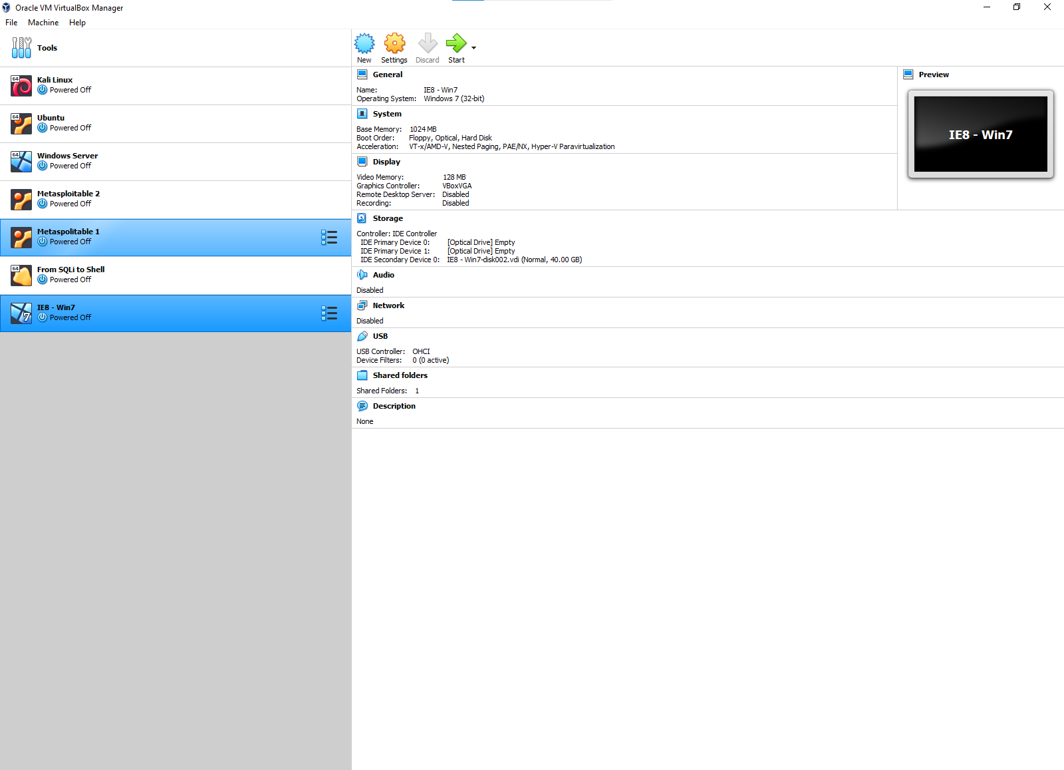

Writing to output1.txt:

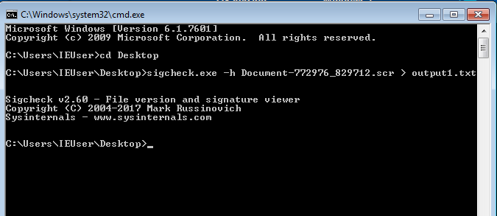

**(I have inserted the other screenshot in their assignments 3.1P)**

**Task 3.1P**

Alice bash:

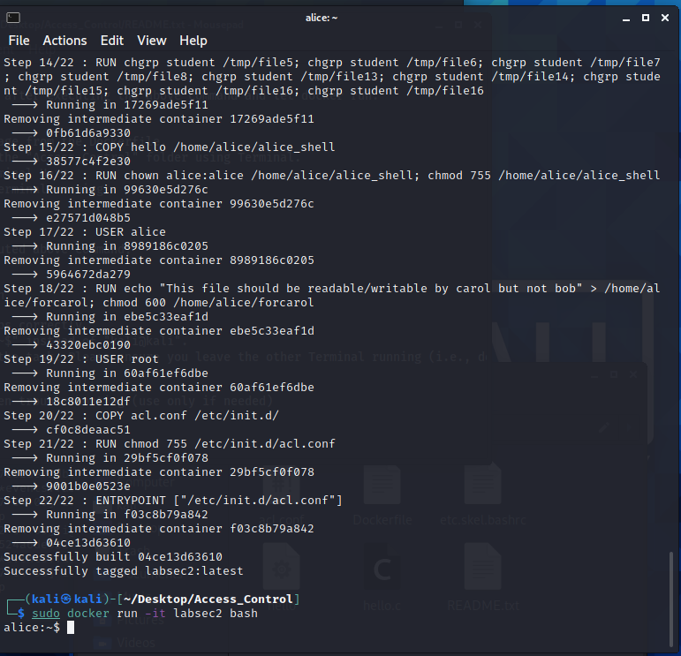

Password for challenge 1:

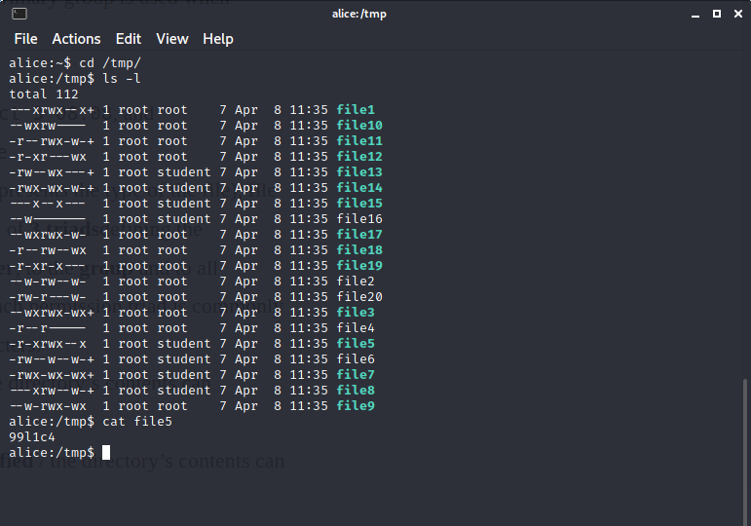

Password for Challenge 2:

chmod 755 myfile

(No Screenshot needed)

Password for Challenge 3:

